
Radiant Souls
Holistic Hypnotherapy Training

Certification Course in Hypnosis:
Friday 26th – Monday 29th of April 2018
Barrow Gurney, Bristol UK

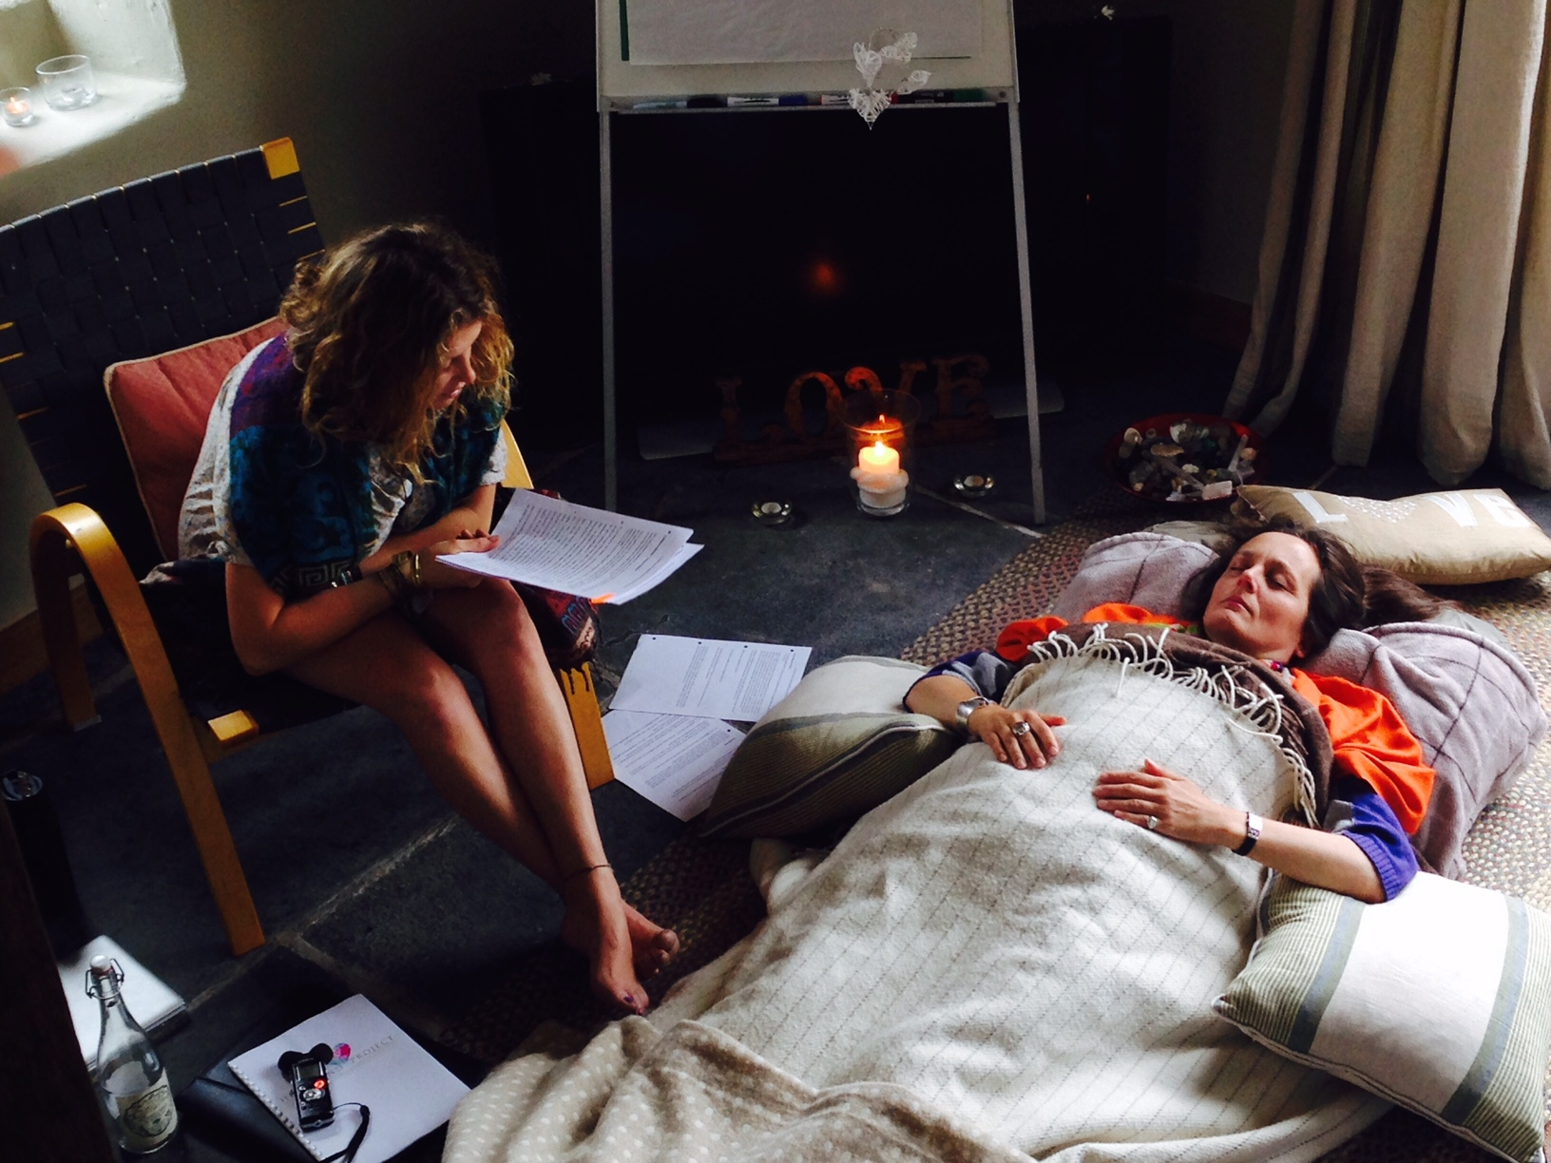

Date

A single 4-day workshop from Friday 26th – 29th of April 2019

9.00 am to 6.00pm, 7 pm on Sunday evening, 4.30pm on Monday.
Please arrive during between 9 - 9.15am on the first morning for a 9.30 start.

Tuition, Supervision and Certification Fee
Early Bird/Conscessions £550 /Full price £650
Early Bird is available for those paying their deposits up to the 30th of March 2019
The balance is to be transferred during the week prior to the course.

The Certification Level Training covers all of the foundations for using hypnosis with clients, during a minimum of 200 hours of study time.

- Inclusive of 60 hours pre-course reading, preparation and theory.
- 36 hours classroom practical and experiential learning.
- 60 hours of supervised case studies, including preparation, delivery and reflection with supervisor.
- 60 hours of post course reading, study, self hypnosis and recording and submission of a professionally created Hypnosis CD/Recording of high standard and Post Course Theory paper.

The tutorial time includes practical lectures, live demonstrations, experiential pair and triad work, interactive discussions, supervised case studies, written and reading assignments.
We also have lots of fun and learn a lot from each other!

The training is suitable for a variety of students from different walks of life. Some with no prior knowledge of using hypnosis or other therapies, others may be experienced therapists or professionals wishing to add hypnosis skills to their tool kit.

Pre course reading books:

“Hypnosis for Change” by Josie Hadley and Carol Staudacher

“Essentials of Hypnosis”, Michael Yapko

**If you are accepted on this course fairly close to the starting date with little time for reading the books, they can be started during the available time and completed after the course.

Please read as much as you can in the meantime!

A comprehensive workbook manual, notepaper and pen will be provided on the course.
You will need to bring preferably your laptops (or tablets) on day 3.

Location
18, The Cottages, Hospital Road, Barrow Gurney BS48 3SF
Please bring a packed lunch each day. Drinks and snacks will be freely provided..

Accommodation – Non residential
Let me know if you need help finding somewhere and I will make some great suggestions.
Please advise me if you will be bringing a car and might be able to assist other students..

Deposit and Payment
A non-refundable deposit of £100 confirms the booking and the balance for the tutor fee is due during the week before the workshop. Payment is by cheque or bank transfer prior to arrival at the course to:

NatWest A/C 41660862 Sort code 602332

Complete this registration form electronically and email it to me at;
hypnoticchanges@yahoo.co.uk

Deposits need to be made by bank transfer - please reference with your name.
E.g. Sadie Smith Dec ‘18 Hyp

REGISTRATION

Name Name to go on the Certificate (if different)
Registration Date

Address

Date of Birth Place of Birth Time if known

Mobile

Email
Website

How did you hear about the course?

Mental Heath Personal History
(i.e. depression, anxiety, any medication you are currently taking, any therapies experienced)

Prior Complimentary or Medical Therapy Training - Therapy, Hours of Training, Training School, End Qualification and Date
(E.g. Psychotherapy, 200hrs, Holistic School, Certificate in Psychotherapy, 2005)

Please describe your experience that demonstrates your level of interest, enthusiasm and life experience appropriate to the ‘helping’ professions and show aptitude and potential for studying. (i.e. nursing, massage/reiki therapist, teaching etc)

Personal Goals for the Workshops (What would you wish to achieve from the training? Are you interested in Advanced training or Diploma level training?)

Radiant Souls
Holistic Hypnotherapy Training

