Hypnotherapy Questionnaire

Hazel Newton

Dip Hyp. Dip RTh, Ct LBL, RGN

Accredited Trainer with the GHSC & Professional Member of GHR – General Hypnosis Register

Professional Member of EARTh - European Association of Regression Therapists

Founder Member of SRTA - Spiritual Regression Therapy Association
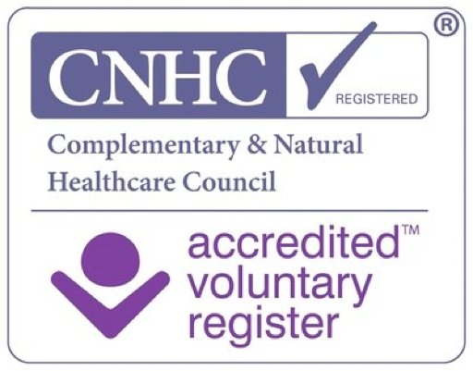

CONFIDENTIAL ENROLMENT QUESTIONNAIRE

Note: All information will be kept strictly confidential except that which I am legally obliged to report, such as a threat of injury to yourself or others. If you are uncomfortable in any way with any of these questions, feel free to skip them. Please be aware that the more you can tell me about yourself, the more I may be of assistance to you. Feel free to use more paper/spacer to go into detail about any issue you wish me to know about you, or to help you with. Please complete and sign the form and return it to me.

Name
Date of Birth Age
Address

Town
County Postcode

Phone
Mobile
Email

Personal Status

Name of Spouse/Partner

Names and Ages of Children

List your 2 favourite colours in order of preference.

List your 2 favourite places in order of preference:

How do you like to relax,

List any fears or phobias

Do you experience any compulsive tendencies?

List any current health problems

Is a doctor treating you? Yes No
If yes, please list?

List any medications you are currently taking

List your three most important lifetime goals:
1
2.
3.

List your three favourite hobbies:

What is your current occupation?

Do you enjoy your work?

Please list things that you would like to do better:

What is your greatest dream for yourself?

Why are you seeking hypnotherapy?

How did you hear about me?

Please tick all that apply

Nervousness Inability to relax Sleeplessness
Depression Nail- biting Nightmares
Sexual dysfunction Compulsive tendencies Teeth grinding
Poor health Alcohol abuse Drug abuse
Cigarette smoking Compulsive overeating Self-mutilation
Serious eating disorder Co-dependency Inability to focus attention
Poor memory Marital problems Recent divorce
War trauma Childhood trauma Illness or death of a loved one
Lack of energy Low self-esteem ADD or ADHD
Abusive home situation Abusive work situation Lack of success

What is the emotional and psychological health of your parents?

Do you follow any religious practices or meditation?

Please list any other conditions occurring in your life that you believe are negatively affecting you in any way. Use additional paper to tell me the details of your concerns, needs or fears.

On a scale of 1 – 10, how badly do you want to stop smoking? ……………………

When did you start smoking?
Please tell me why you started?
- Peer pressure
- Rebelling against authority
- Mother or Father smoked
- To appear more adult
- To appear more sophisticated
- Other

How many do you smoke a day? Which brand do you smoke?

For how long have you smoked that many?
What do you get from smoking?
- It relaxes me
- It helps me concentrate
- Its an excuse for a break
- It gives me a confidence boost
- It’s a prop
- Other

When do you smoke?
- On waking
- At breakfast
- With tea/coffee
- After meals
- On the telephone
- Whilst driving
- At work
- In bed
- Other

What frightens you about smoking?

Do you know someone who
- Died from a smoking related disease
- Who is ill now?

Who is important to you?
WHY

What else is important to you?

Has your doctor mentioned your smoking to you?
Have you had any warning signals or symptoms?
Do you have any health problems?

How long do you want to live? Why?

Whose responsibility is your health?

What will you be able to do as a non-smoker that you couldn’t do before?

What will you do with the money you save?

Do you really want to quit?
What is stopping you?
Comments.

Main reasons you want to stop:
1.
2.
3.

RELEASE STATEMENT

I hereby authorize Hazel M Newton to help me to hypnotise myself for the purposes outlined in this form, and for future purposes that I may request. I understand that hypnosis is not a medical procedure and that no medical benefits are being offered to me. I understand that the success of my hypnosis therapy depends on my ability to relax and my desire to create change in myself. I understand that, because the results of hypnosis sessions depend on my own serious participation, Hazel Newton cannot offer any guarantee of the success of my treatment. I am aware, however, that she will do everything reasonable in her ability to ensure my success.

Signature: _____________________________________________________ Date:________________

Please Note: I can often re-arrange appointments if necessary but if you need to rearrange or cancel with less than 48 hours notice, I will need to charge you for your missed appointment.

Checklist for Discovering Learning Channels
(Please mark the number of any item that seems like something that fits your nature)

Auditory Learning Channel indicators
- Prefers to have someone else read instructions when putting a model together.
- Reviews for a test by reading notes aloud or by talking with others.
- Talks aloud when working on a maths problem
- Prefers listening to a cassette over reading the same material
- Commits a number to memory by saying it repeatedly.
- Uses rhyming words to remember names.
- Plans the upcoming week by talking it through with someone.
- Likes to stop and ask directions.
- Prefers oral instructions from an employer.
- Keeps up on news by listening to the radio.
- Able to concentrate deeply on what another person is saying
- Uses free time for talking to others.
- Sings or plays a musical instrument well.
- Prefers talking/listening games.

Visual Learning Channel Indicators
  - Likes to keep written notes.
  - Typically reads a billboard while driving.
  - Puts a model together correctly using written directions.
  - Follows written recipes easily when cooking.
  - Reviews for a test by writing a summary.
  - Writes on napkins in a restaurant.
  - Commits a number to memory by writing it down.
  - Can put DIY furniture together from instructions.
  - Uses visual images to remember names.
  - Loves to read books.
  - Plans the upcoming week by making a list.
  - Prefers written directions from an employer.
  - Prefers to get a map and find own way.
  - Prefers reading/ writing games SCRABBLE

Strong In Touch movement (kinaesthetic) Channel
- Likes to build things.
- Uses sense of touch to put a model together
- Can distinguish items by touch when blindfolded.
- Learns touch system rapidly in typing.
- Moves with music.
- Doodles and draws on any available paper.
- An out of doors person.
- Moves easily; well co-ordinated
- Spends time on crafts and handiwork.
- Likes to feel texture of materials.
- Prefers movement games to games where one just sits.
- Finds it fairly easy to keep physically fit
- One of the fastest in a group to learn a new physical skill.
- Uses free time for physical activities.

